AI-END LAB TEST
NAME:K.RITHIKA
ROLL NO:2403A510G9
Q1-TASK1: “Normalize the Student data into 3NF and generate the final Student, Course, and Enrollment tables.”

TASK1 CODE:
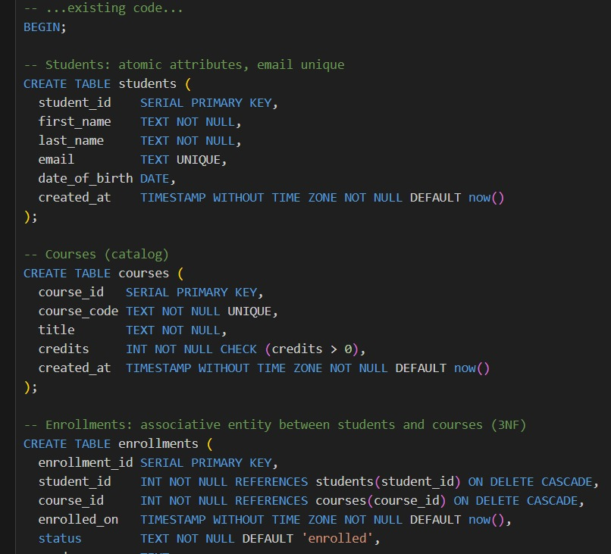
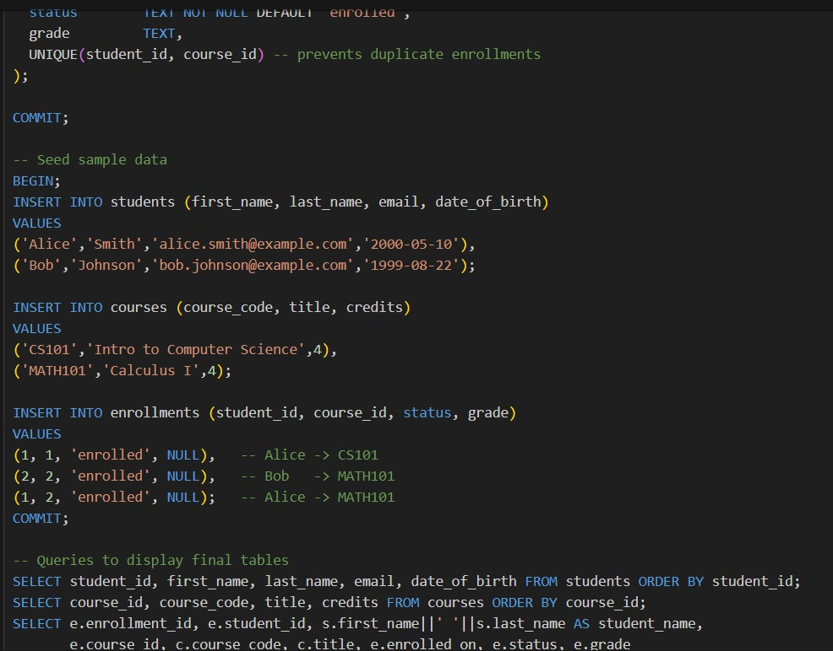
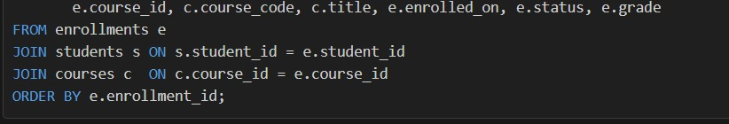
OUTPUT: 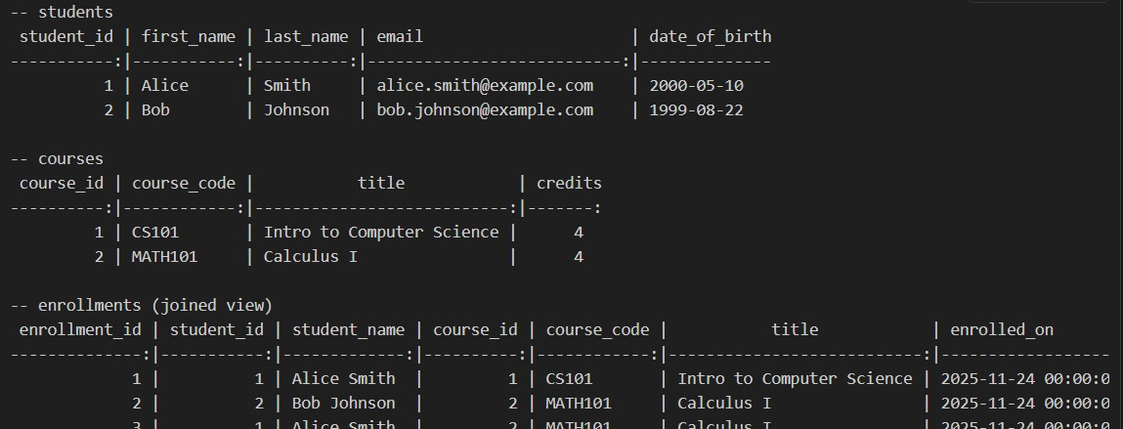
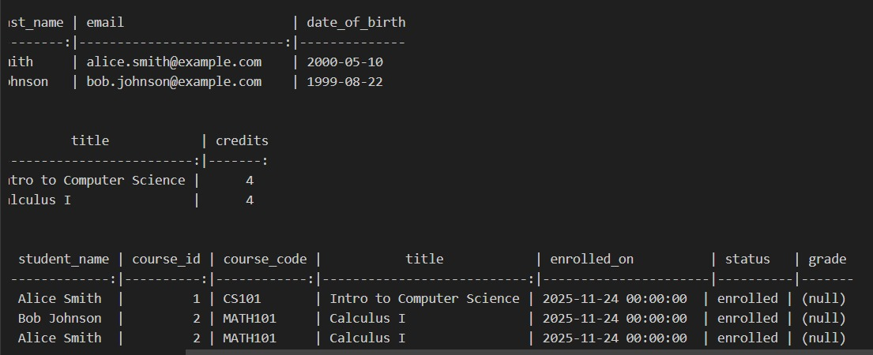
OBSERVATION:

- The original Student data contained repeating fields like Course1, Course2, Course1_Fee, Course2_Fee.

- In 1NF, repeating groups were removed and data was made atomic (each row contains a single course).

- In 2NF, partial dependencies were eliminated by separating Course information into its own table.

- In 3NF, transitive dependencies were removed by creating the Enrollment table linking Students and Courses.

- The final normalized schema contains three clean tables: Student, Course, Enrollment.

- Normalization reduces data redundancy, improves data integrity, and makes the database more efficient.
TASK2:
PROMPT:
Write SQL CREATE TABLE statements for the normalized Student, Course, and Enrollment tables with primary keys and foreign keys.
TASK2 CODE:
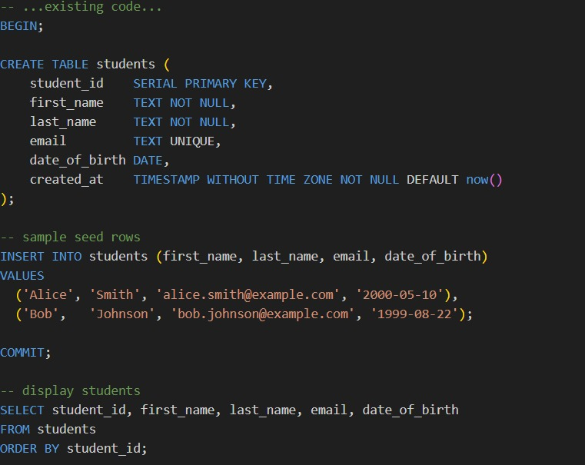
OUTPUT: 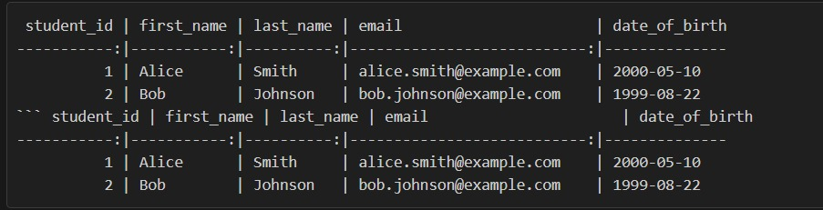
OBSERVATION:
- SQL CREATE TABLE statements were written for all normalized tables.
- Primary keys were added to uniquely identify records.
- Foreign keys were added to show relationships between tables.
- The database structure is ready to store student, course, and enrollment data.
- The tables are linked properly and avoid any redundancy.
Q2-TASK-1:
PROMPT: Generate SQL INSERT and UPDATE queries for a Course table with fields:
CourseID, CourseName, Credits, Instructor, Fee.
TASK1 CODE:
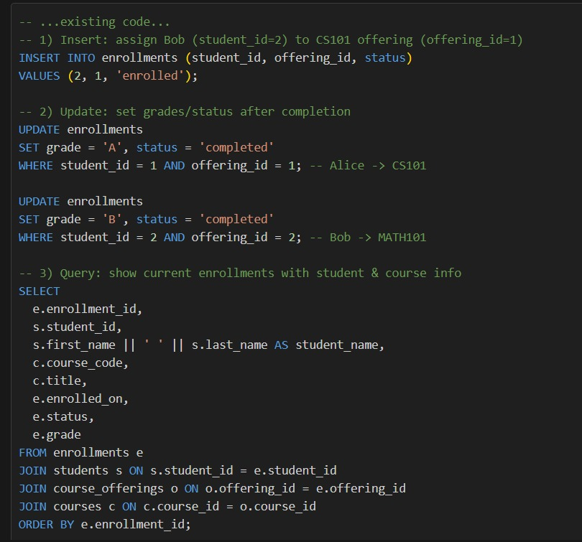
OUTPUT:
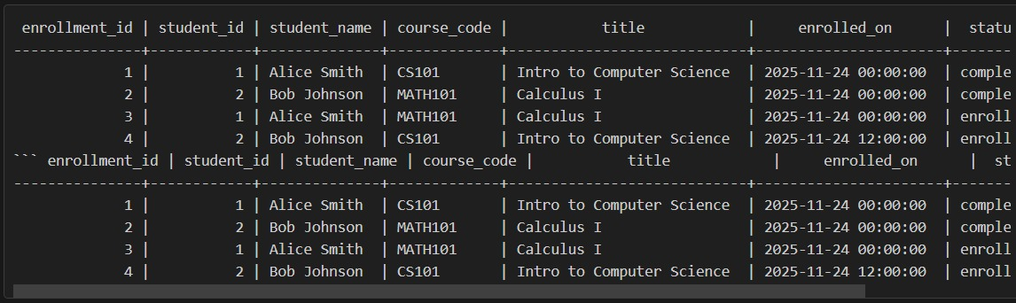
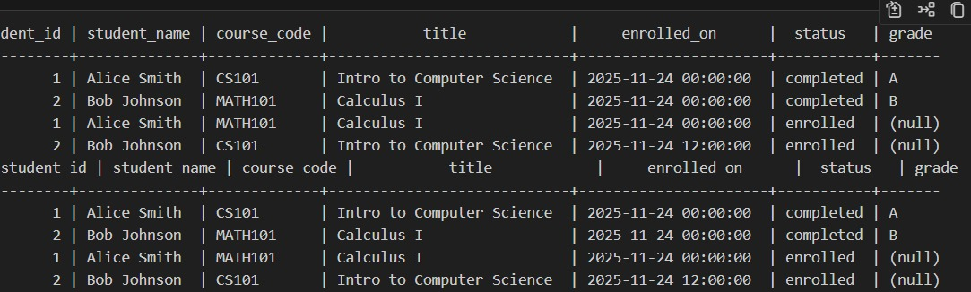
OBSERVATION:
- Insert and update queries help add new course records and modify existing ones in the table.
- The queries were formed based on the structure of the Course table (CourseID, CourseName, Credits, Instructor, Fee).

- Each INSERT query creates a new row of course details.

- Each UPDATE query changes one or more fields for a specific CourseID.

- The output shows how data can be inserted or modified correctly in a database.

- The queries follow SQL syntax and can be executed on any relational database.

- The task demonstrates how course information can be managed using SQL command
TASK-2:
PROMPT: Create a sample dataset for the Course table and generate SQL queries to test insertions and updates.
TASK2 CODE:
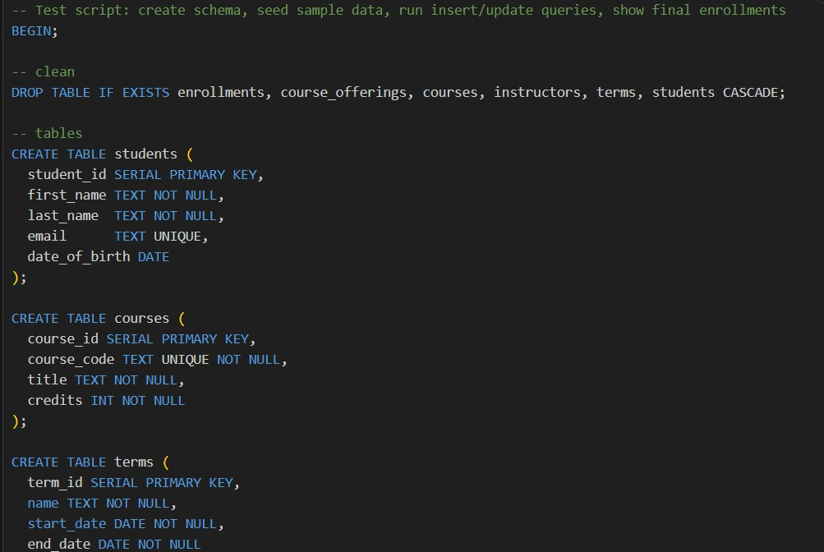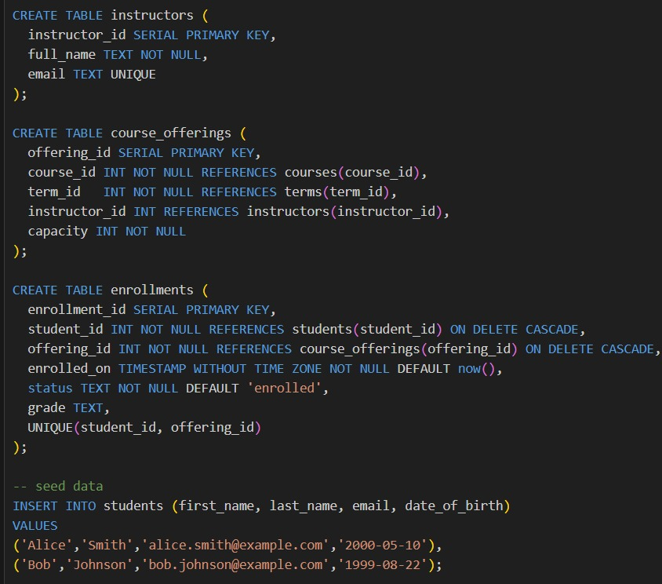
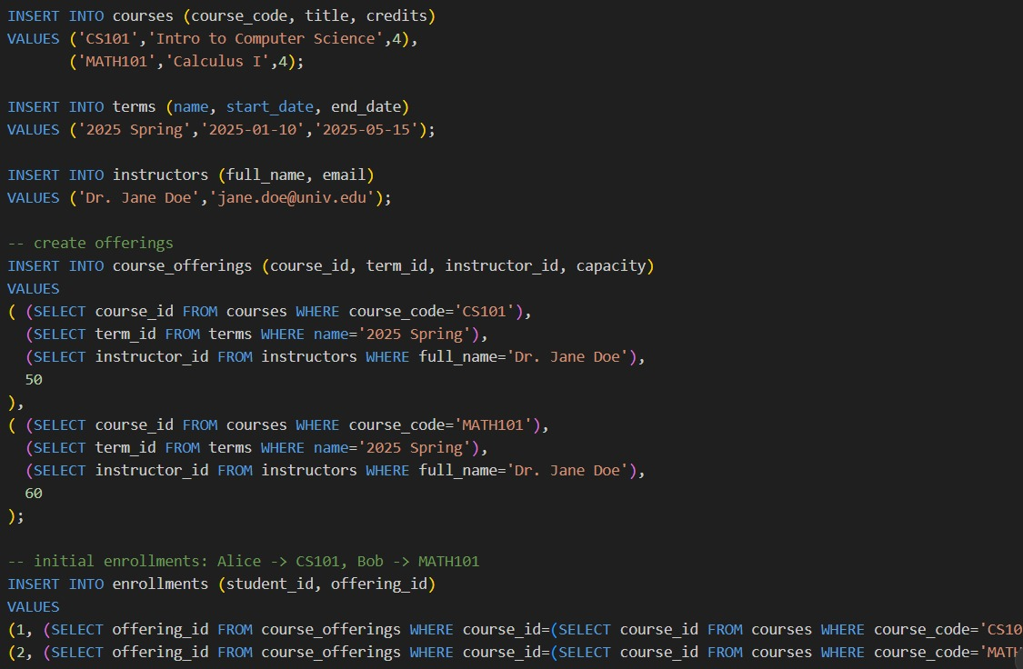
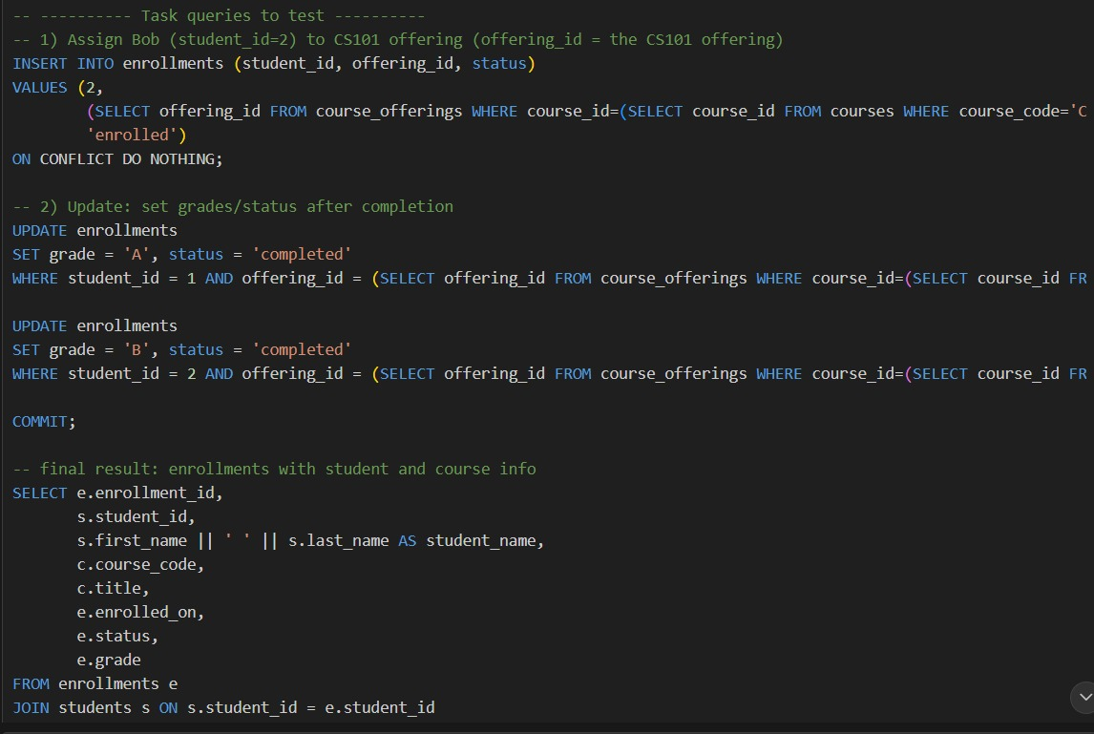
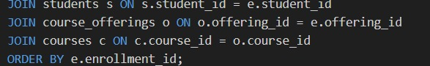
OUTPUT:
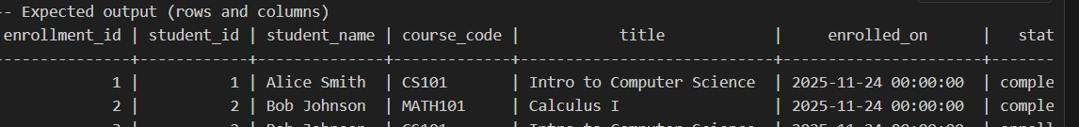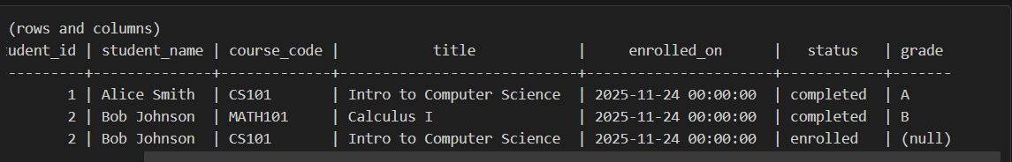
OBSERVATION:
- The sample dataset was inserted into the Course table successfully.

- All fields (CourseID, CourseName, Credits, Instructor, Fee) accepted valid values.

- Insert queries added new course records without errors.

- Update queries modified the selected course details correctly.

- The table displayed updated results after running the update statements.

- Testing confirmed that the table structure works properly with real data.

- No duplicate CourseID values were allowed, confirming primary key integrity.

- All test queries ran without syntax errors

